**VPC Peering :Communication Between VPC’s**

**1)Vpc list:**

**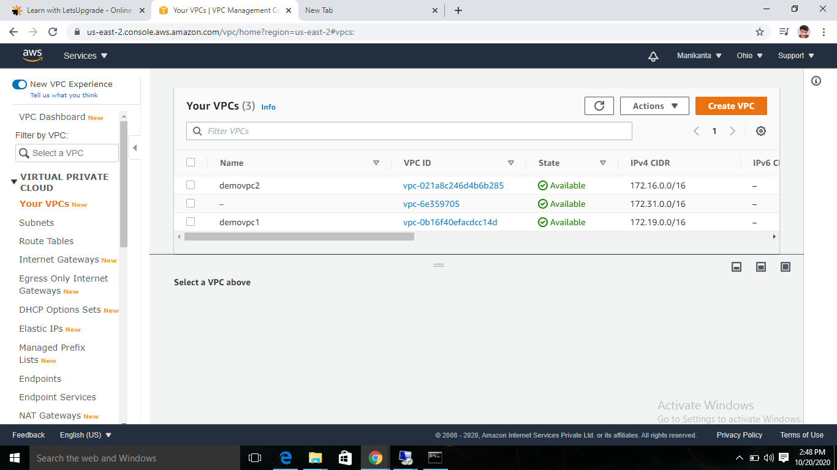  
first vpc demovpc1:**

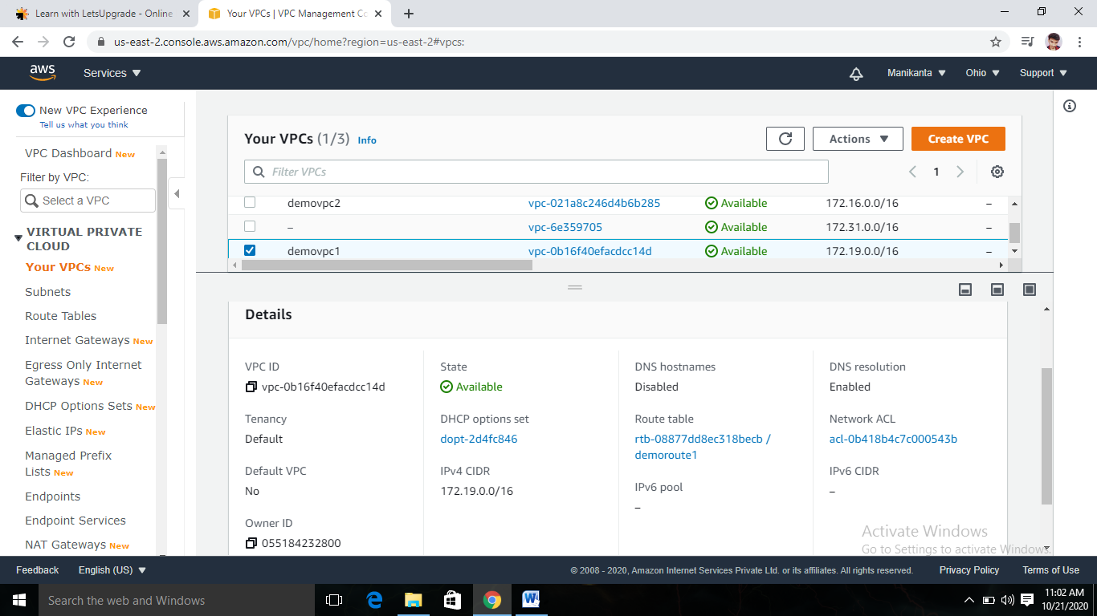

**Seconds vpc:demovpc2**

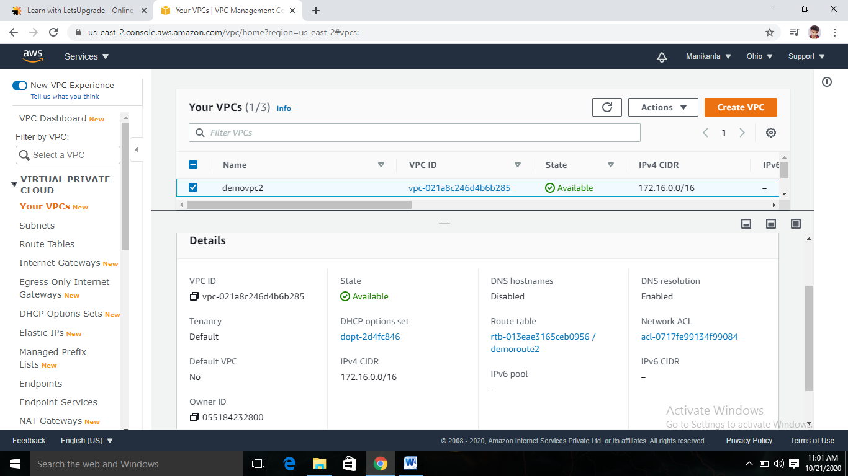

**2)Igw List:**

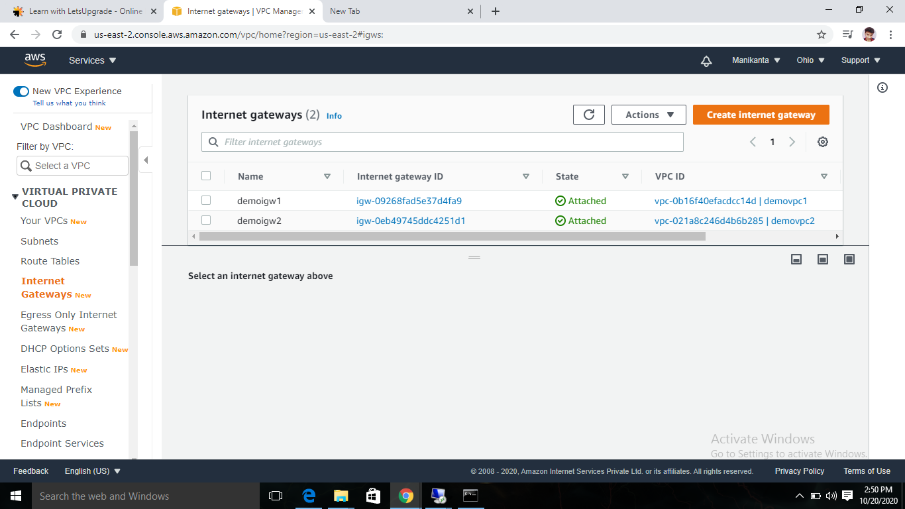

**First igw connected to vpcdemo1**

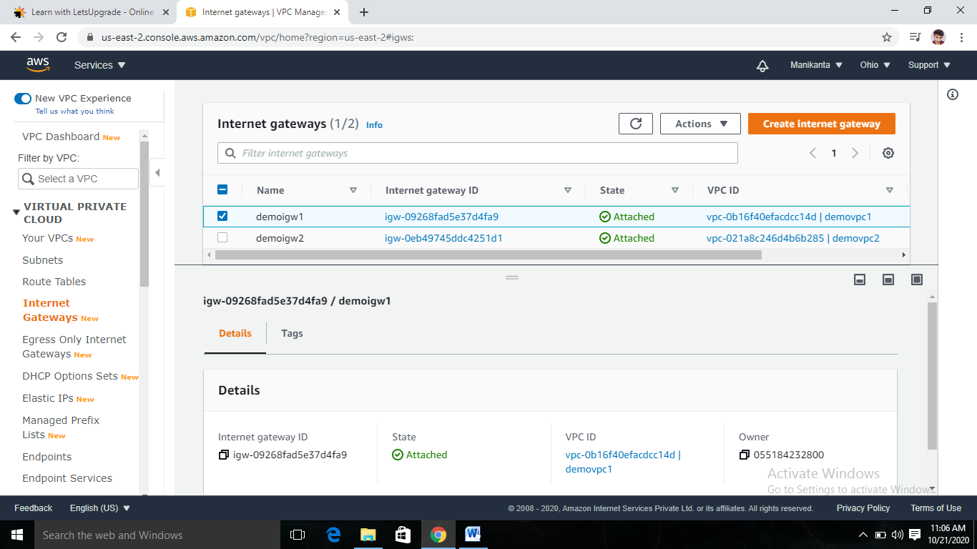

**Second igw connected to vpcdemo2**

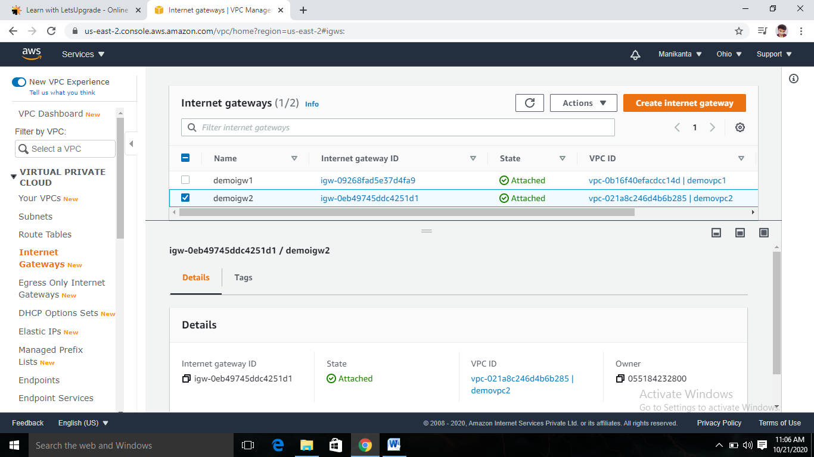

**3)Edit Route List:**

First route table:demoroute1

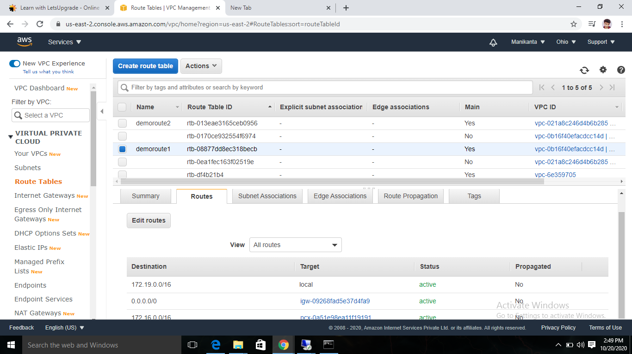

Second route table:demoroute2

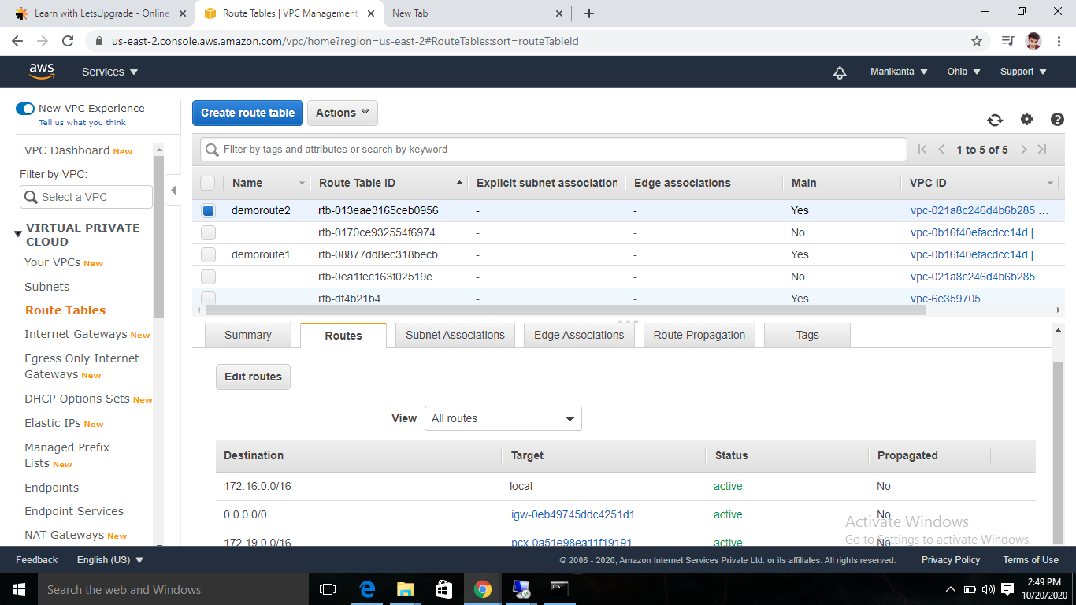

**4)Subnet list:**

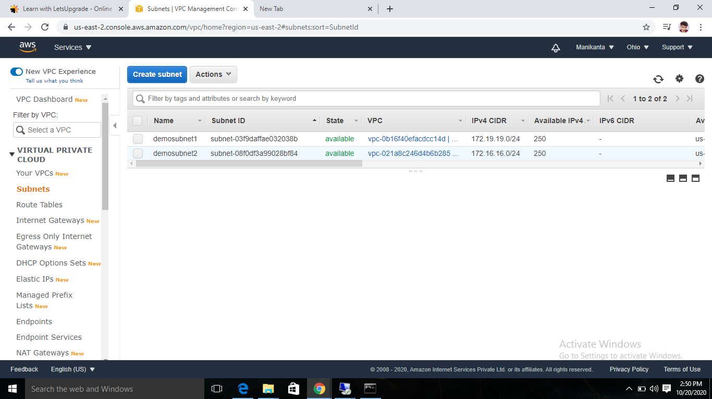

**Demosubnet attached to demovpc1:**

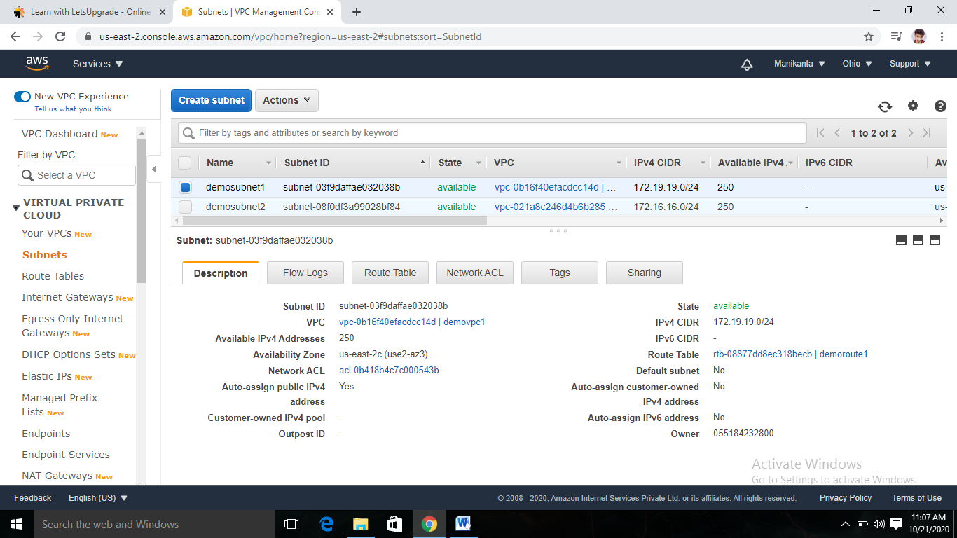

**Demosubnet2 attached to demovpc2**

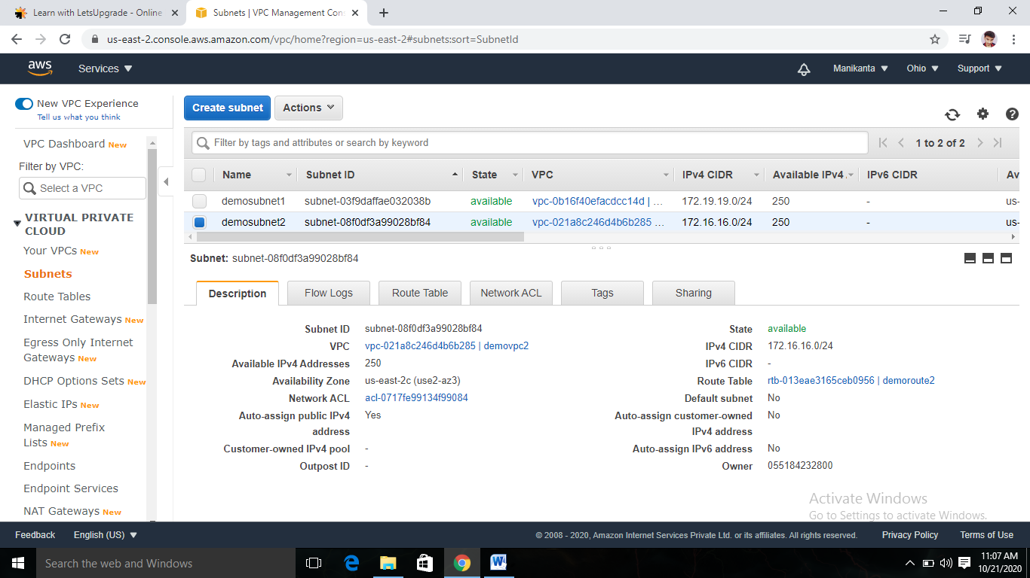

**5)Instance details:**

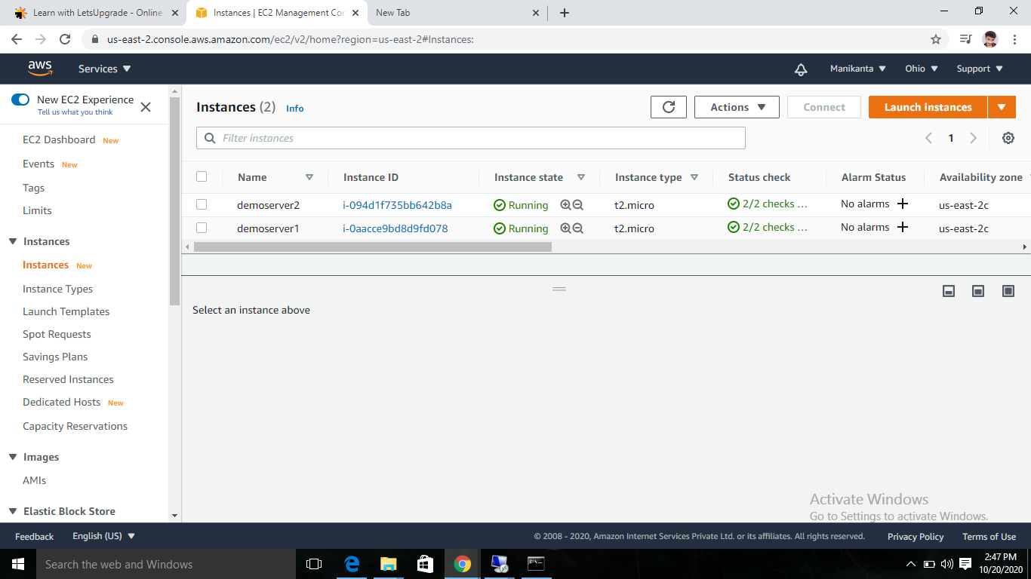

**Instance1**

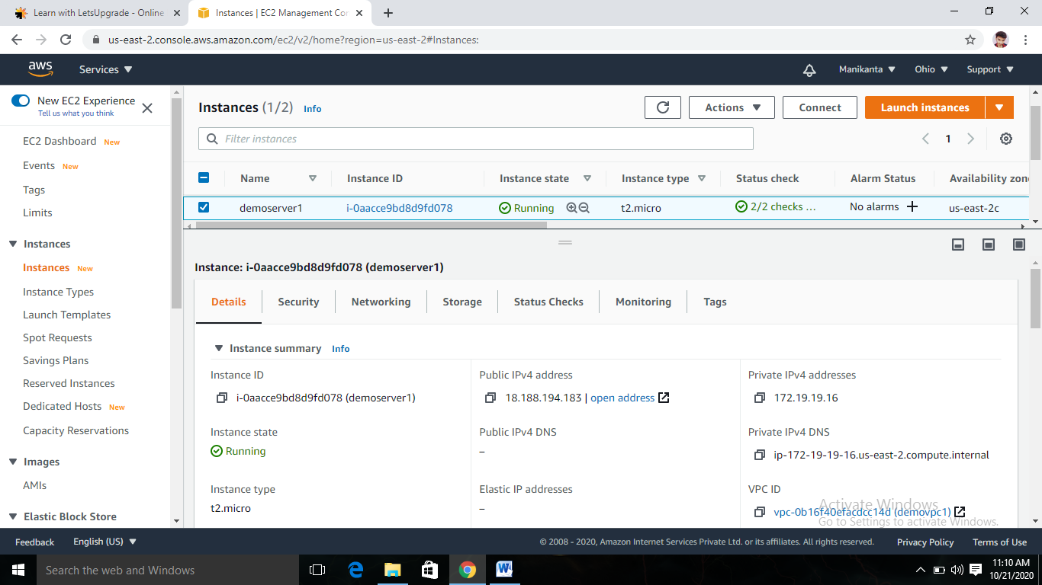

**Instance2**

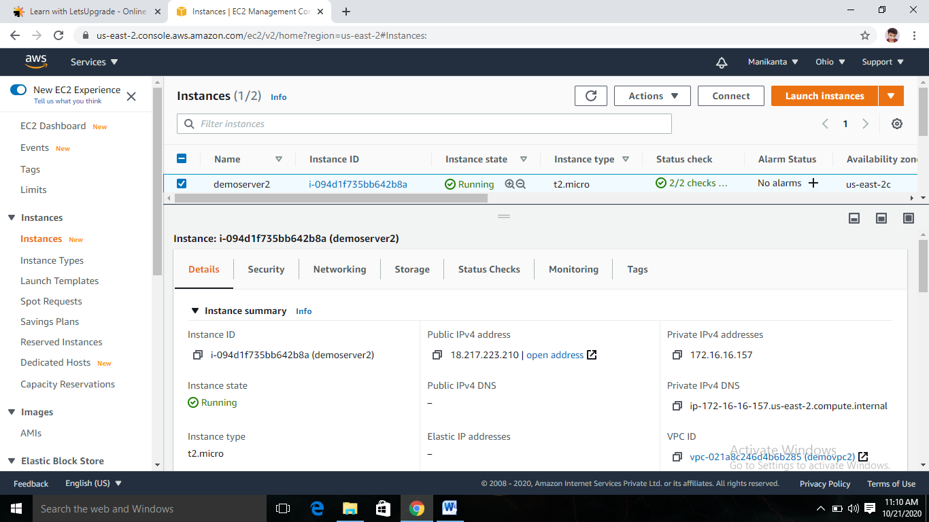

**6)** **success public:**

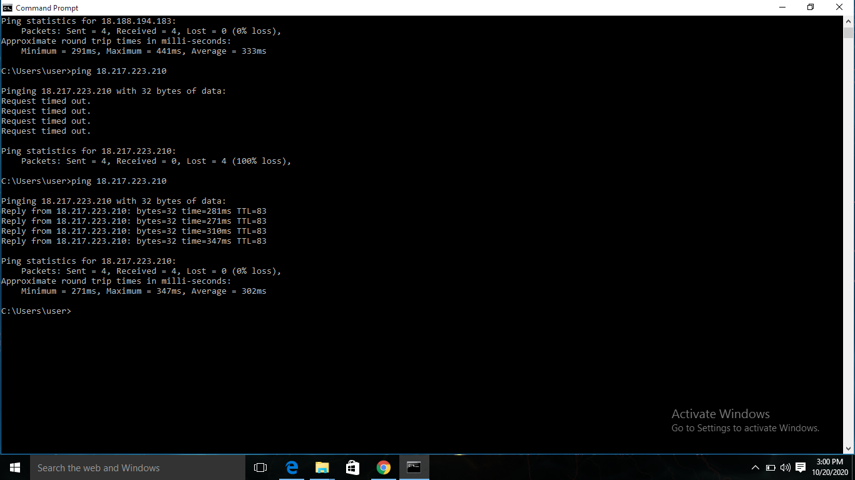

**Requestimedout private IP:**

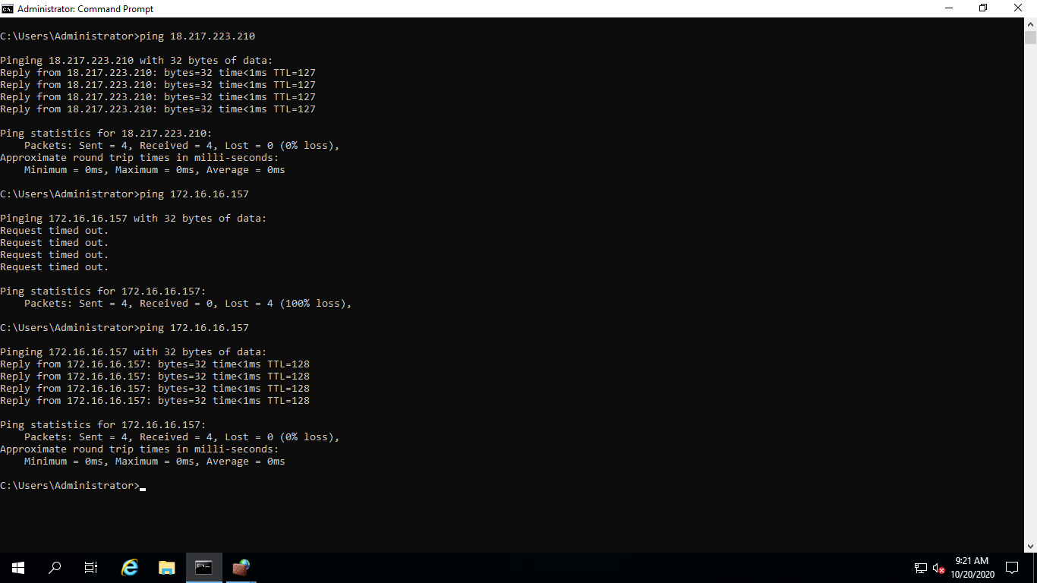

**7)** **Peering with req and acceptor:**

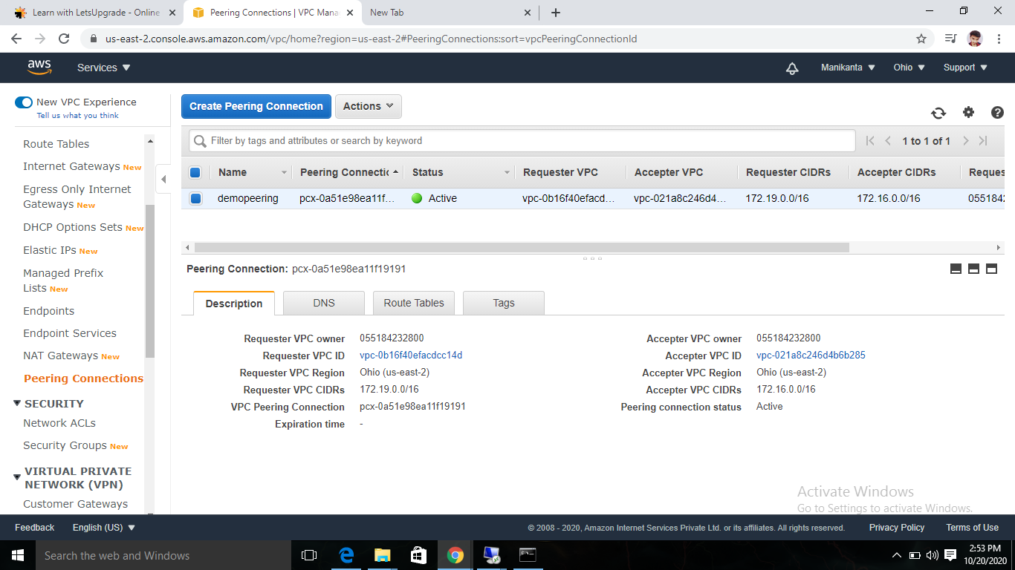

**8)Success Private:**



**Project 2: IAM**

Task 1:Creating users permissions-IAM password policy check

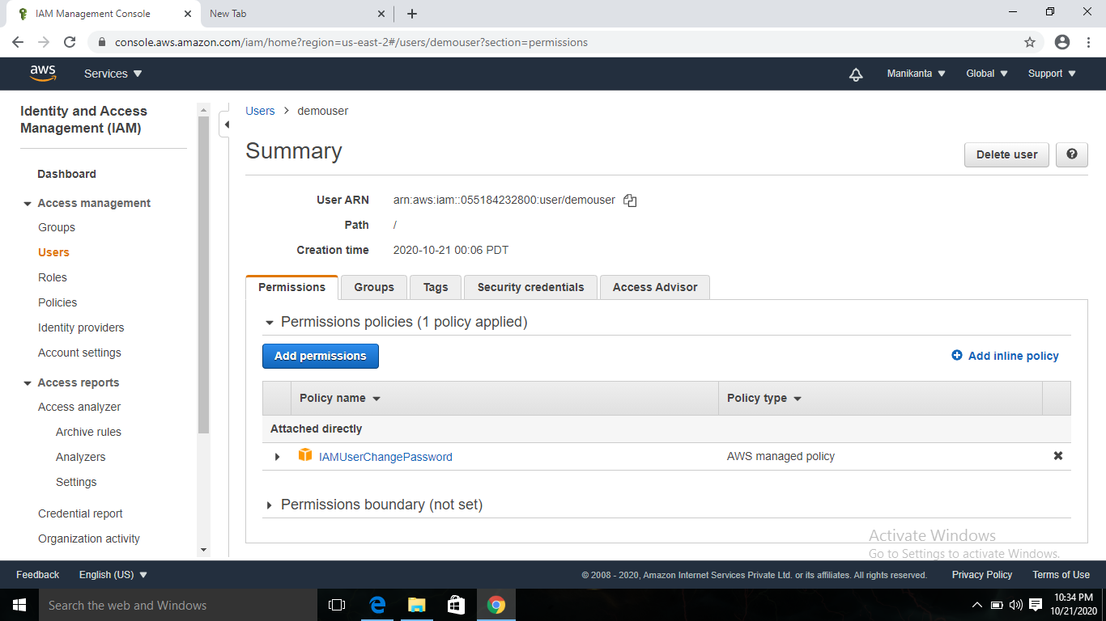

Task 2:Creating users without the IAM password policy

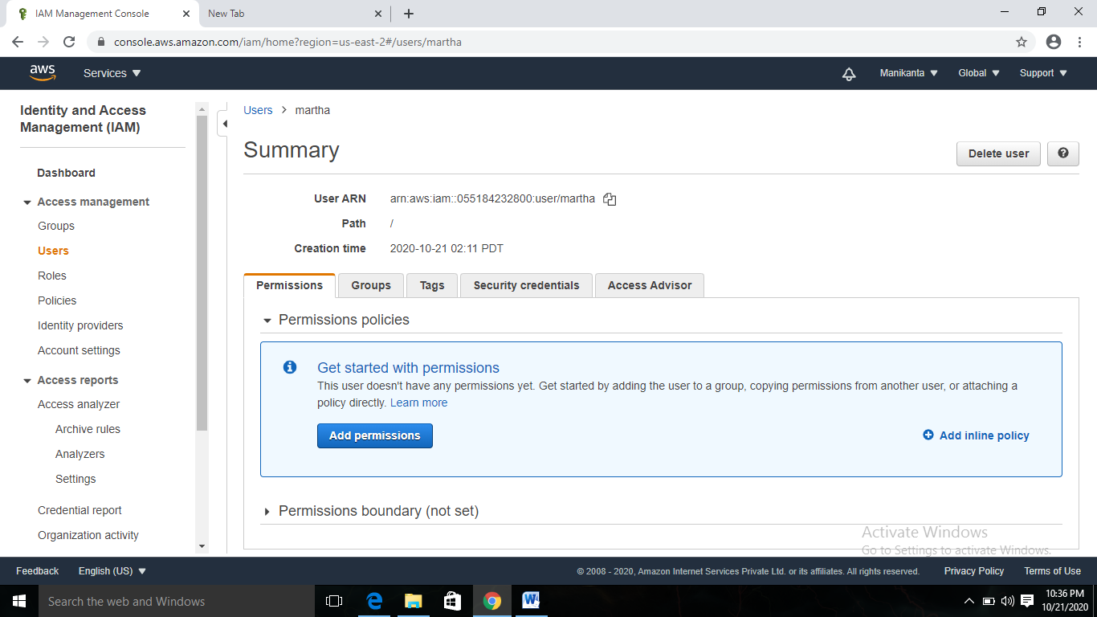

Task 3:Create a user with S3 full access

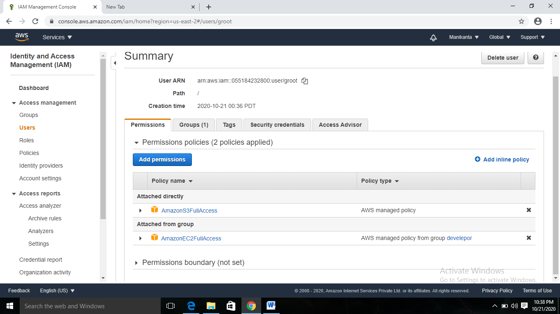

Task4: Create a group with ec2 full access

Users data

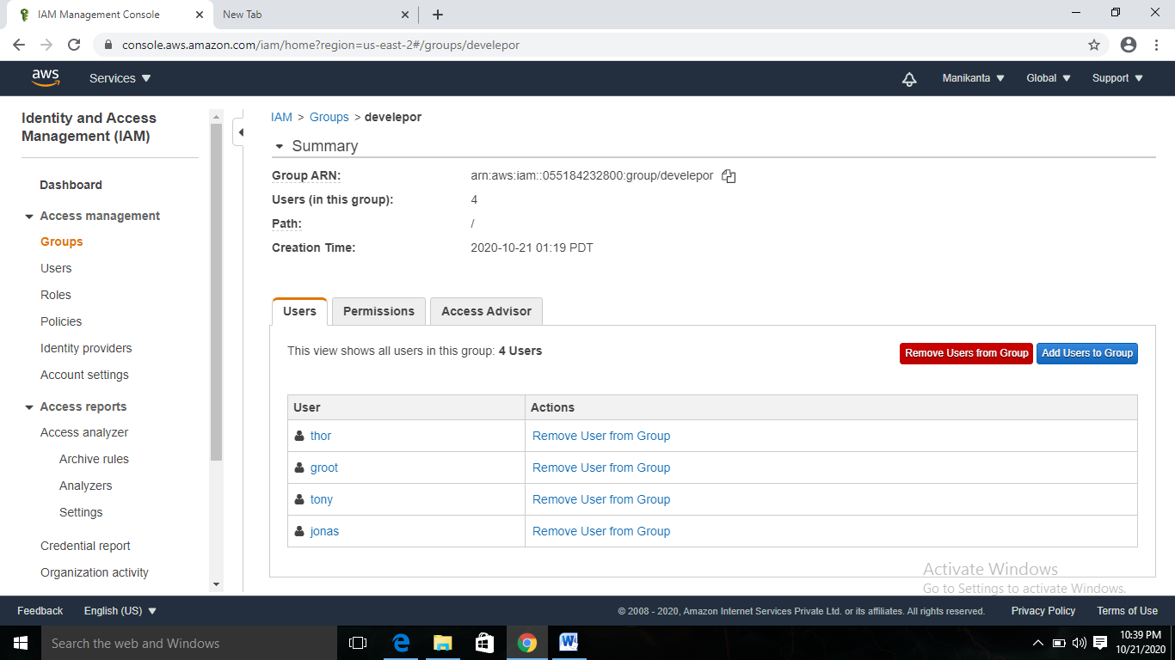

**Permission**

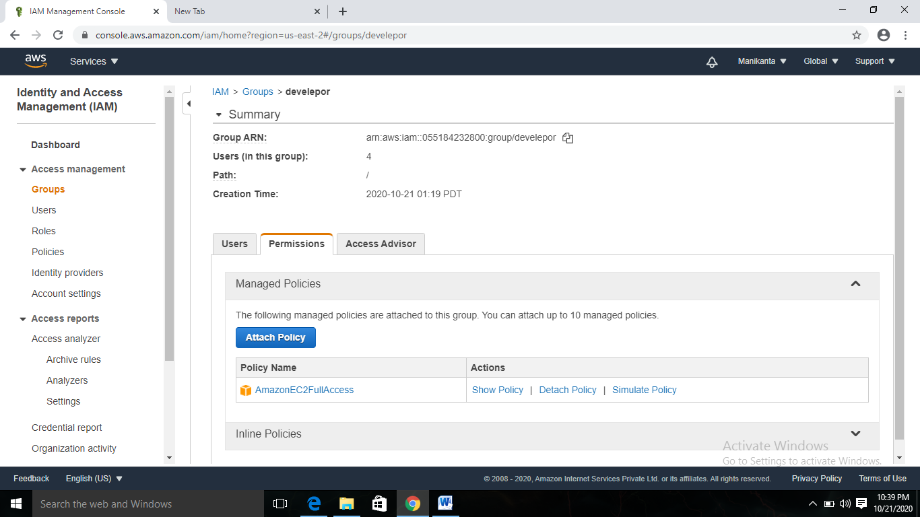

Task 5:Add user to a group and check if user policy and the group policy is reflecting on the user

User with s3 user policy and ec2 group policy

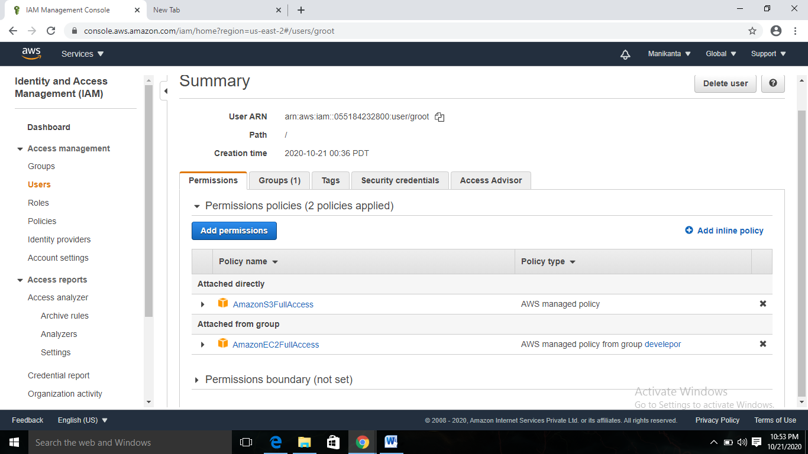

User policy s3 fill access getting the data from root user

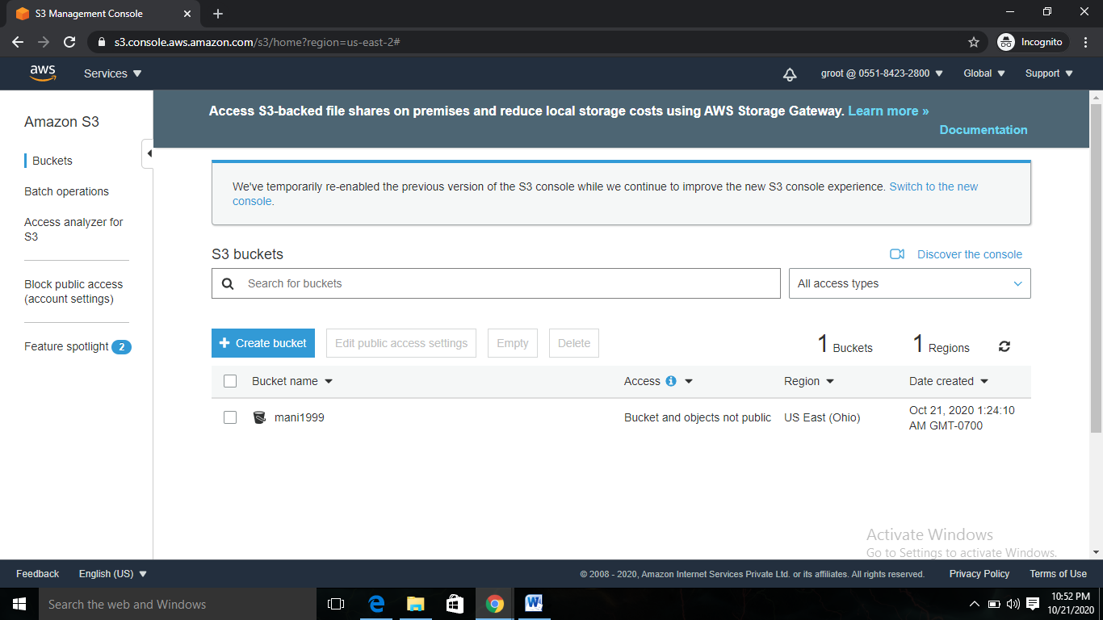

Group policy also working ec2 full access

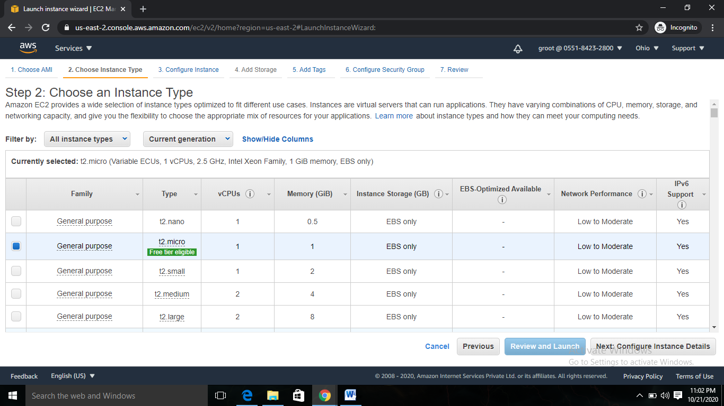

Task 6:Copy policies from the existing user

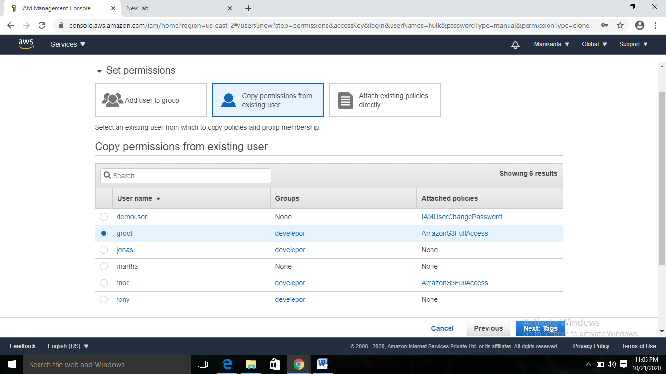

S3 user policy working

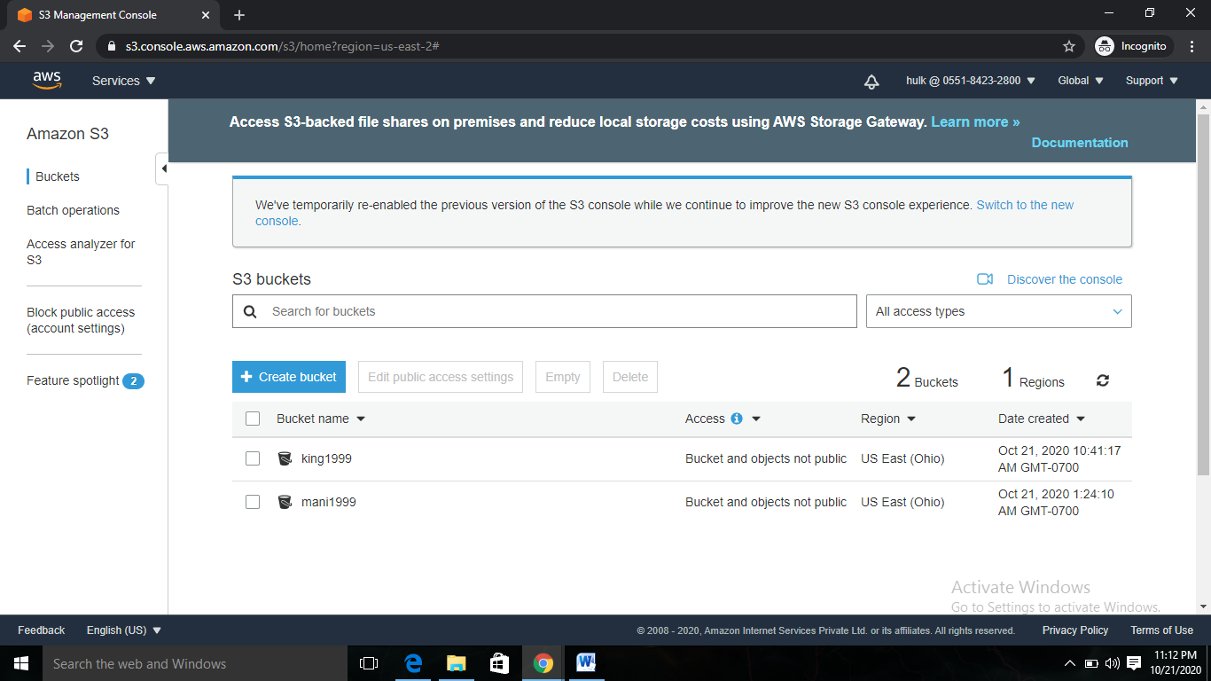

**Setting password policy:**

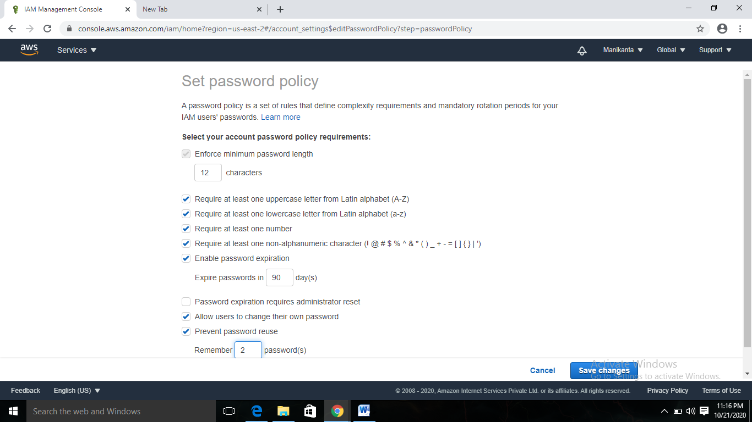

**Password incompatibility error:**

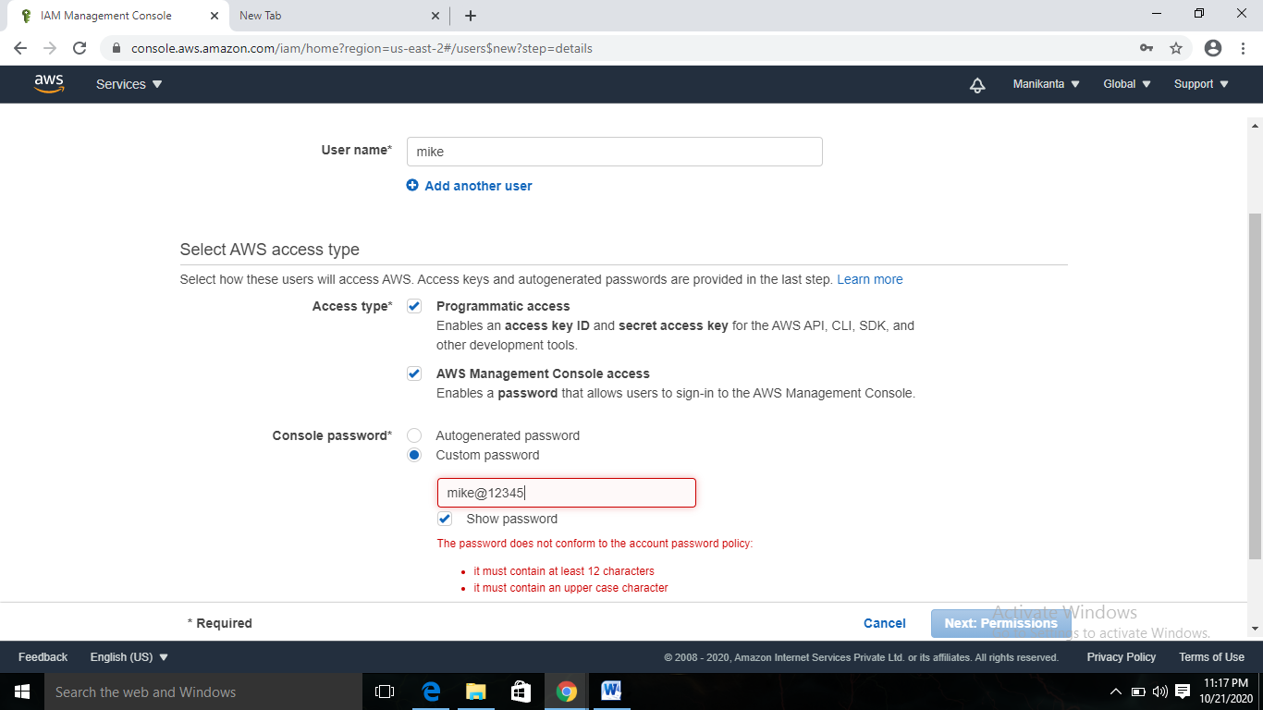

Enable MFA:

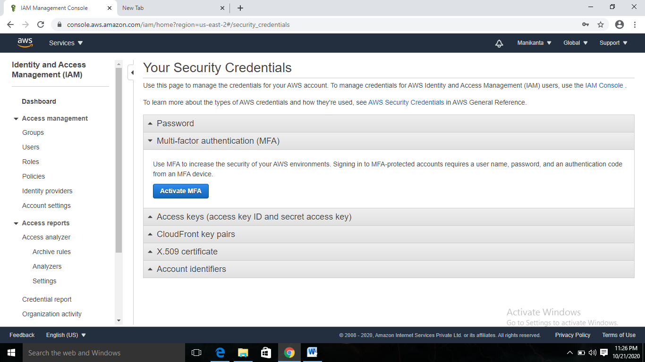

Scanning qr code :

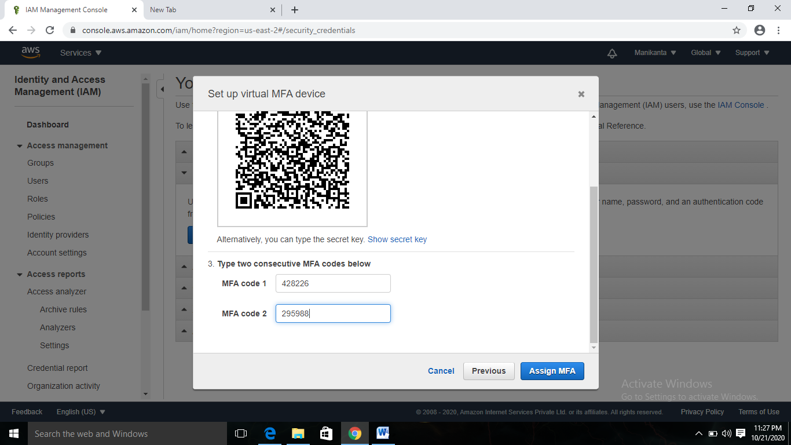

**Login Screen for root account with MFA:**

